AGENDA
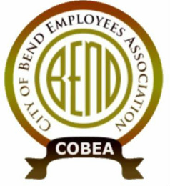
Meeting: COBEA EBoard Meeting
Date: 4/28/2021, 4:30 PM – 6:30PM
Attendees:
❍ Kerry Bell – President  Julie Craig -Vice President  Julie Oconnor – Secretary  Sean Quinlivan – Treasurer
Nick Patten – ST Downtown main campus  Matt Ziebol - ST Boyd  Mike Niles - ST Wall Annex  Roy Bradley - ST WRF  Nolan Holmgren – ST 15th alternate  Lori Davison – downtown main alternate  Joe Holmgren – Boyd alternate  Lanelle Duran – Wall Annex alternate  Cally Whitman – WRF alternate  Tedesco Law Firm - Representation

Call to Order: President
REPORTS: (15min)
1. Officer Reports
- Secretary Report (3min) –
- Treasurer Report (3min) -
- Vice President Report (3min) -
- President Report (5min) - grievance, DUI and public records request of email, Tony Cota’s resignation
vISITOR cOMMENTS
New GENERAL Business: (up to 1.5 hrs)
- New hire Orientations
- initial Bargaining survey
OLD General business
Upcoming Meetings: Board meeting May 13?
Steward Reports: (ROUND TABLE up to 3min each as time has allowed)
Close Meeting

