AGENDA
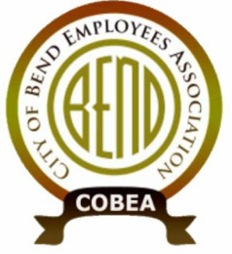
Meeting: COBEA EBoard Meeting
Date: 1/27/2021, 4:30 PM – 6:30PM
Attendees:
❍ Kerry Bell – President  Julie Craig -Vice President  Julie Oconnor – Secretary  Sean Quinlivan – Treasurer
❍ Tony Cota – ST 15th Nick Patten – ST Downtown main campus  Matt Ziebol - ST Boyd  Mike Niles - ST Wall Annex  Roy Bradley - ST WRF  Nolan Holmgren – ST 15th alternate  Lori Davison – downtown main alternate  Joe Holmgren – Boyd alternate  Lanelle Duran – Wall Annex alternate  Cally Whitman – WRF alternate  Tedesco Law Firm - Representation

Call to Order: President
REPORTS: (15min)
1. Officer Reports
- Secretary Report (3min) –
- Treasurer Report (3min) -
- Vice President Report (3min) -
- President Report (5min) - investigations and inquiries by HR
vISITOR cOMMENTS
New GENERAL Business: (up to 1.5 hrs)
- New hire Orientations
  - catch up since COVId
  - electronic welcome packet
- budget
- Looking ahead
  - Goals for connection and communication
    - Updates
    - brown bags during COVID
  - Bargaining prep
    - survey in spring
    - team selection in summer
    - prep in fall
OLD General business
Upcoming Meetings: Quarterly January 28th 5pm via Teams
Steward Reports: (ROUND TABLE up to 3min each as time has allowed)
Close Meeting

