AGENDA
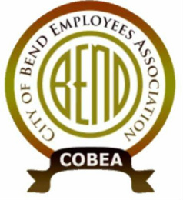
Meeting: COBEA Membership Meeting #2 - 2017
Date: Monday, April 24, 2017, 5:30 – 7:00 pm
Pappy’s Pizza
Attendees:
❍ Brice Blackwelder – President  Donna Hamilton - Int. Vice President  Darcy Todd – Treasurer  Julie DeVoe – Secretary
❍ Julie Price – Int. Communications  Robyn Somers – ST BYD  Carl Howe – ST 15th  Tony Cota – ST 15th
❍ Sandra Roberts – ST IT/EIPD/Gmt Julie O’connor – UT Bill/Fin.  Erynne Fore – ST WRF  Nick Patten – ST Fin
❍ Corey Mastrud-ST WFF  Rick Kuss - ST BOYD  Cathleen Carr – CDD  Josh Oliver - ST 15th

Call to Order: Brice Blackwelder – Welcome Members
  - Introduction of Board
- MINUTES FROM LAST MEETING:
  - Approve Minutes from 1/22/17 Meeting
- FINANCIALS:
  - Update on Financials – Darcy Todd
- BUSINESS:
  - Representation - Update
  - Quarterly Meeting Date Change -
  - By-Laws - Define Eboard Roles & Responsibilities / Spread job duties throughout Eboard
  - Boot MOU
  - Unit Clarification MOU
  - PERS Update
- Meeting Adjourned
- action items/NOTES
Who | What

