AGENDA
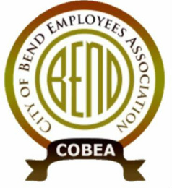
Meeting: COBEA EBoard Meeting
Date: 7/21/2021, 4:30 PM – 6:30PM
Attendees:
❍ Kerry Bell – President  Julie Craig -Vice President  Julie Oconnor – Secretary  Sean Quinlivan – Treasurer
Nick Patten – ST Downtown main campus  Matt Ziebol - ST Boyd  Mike Niles - ST Wall Annex  Roy Bradley - ST WRF  Nolan Holmgren – ST 15th alternate  Lori Davison – downtown main alternate  Joe Holmgren – Boyd alternate  Lanelle Duran – Wall Annex alternate  Cally Whitman – WRF alternate  Tedesco Law Firm - Representation

Call to Order: President
REPORTS: (15min)
1. Officer Reports
- Secretary Report (3min) –
- Treasurer Report (3min) -
- Vice President Report (3min) -
- President Report (30?min) - forced voluntary demotion, retaliatory intimidation and 1st amendment rights, paid leave investigations in Muni Court, PDQs, IT study, positive drug test for cocaine, telematics coming, holiday pay for 4th grievance by member
vISITOR cOMMENTS
New GENERAL Business: (up to 1.5 hrs)
- select bargaining committee
- elections
  - who intends to run AGAIN?
  - recruitment
OLD General business
- New HIre orientations
- Data Analytics and technology study
- Fair pay study
Upcoming Meetings: Board meeting July14th
Steward Reports: (ROUND TABLE up to 3min each as time has allowed)
Close Meeting

